Hello,
This is the help file which will show you how to customize the Blorange site template so you can make it your own.
When you open the source folder you will see two folders:
- Template which contains the website files.
- PSD which contains the Photoshop source files.
The fonts used in the PSD layouts can be found at:
Desyrel: http://www.dafont.com/desyrel.font
Tahoma: system font

The main structure of the HTML files is shown below. The content that you will be interested in modifying is in the “wrap” div element which contains 3 elements: the header, the content and the footer.

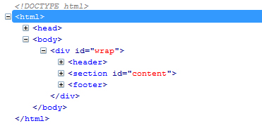

- The header contains the logo, navigation and the top statement. This element is almost the same on each page.
- The content contains the elements that will change as you browse through the website
- The footer contains general information and it is almost the same on each page.

Next, we’ll go through the most important files of the template to see how they are organized and how you can customize them.

HTML FILES
INDEX
A more detailed structure of the homepage is shown below.
The id attribute contains a description of each element.
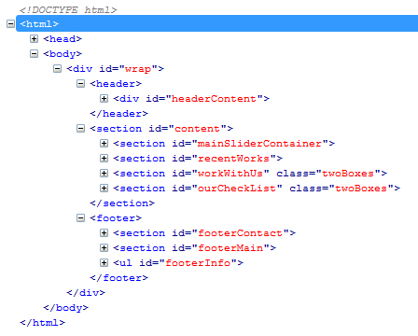

- The Header
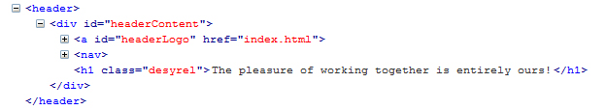
- within the headerLogo element you will find the image logo.
- within the nav element you will find the main navigation.
- the h1 element contains the top statement.

- The Content
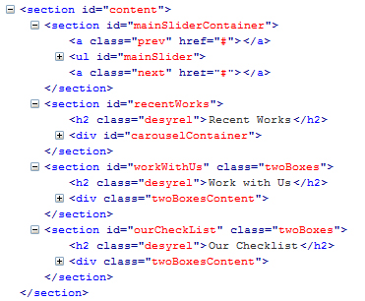

- the mainSlider element contains the slider at the top of the page. To edit the slider go within the element and edit the span, img and p elements
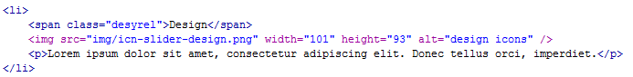

- the recentWorks element contains the carousel below the main slider. To edit the carousel go within the element and edit the h2 and img element which contains the path to the image you want to display in the src attribute.

- the workWithUs element contains an image of the team, a block of text and a link. To edit the section go within the element and edit the h2, img, p and a elements.
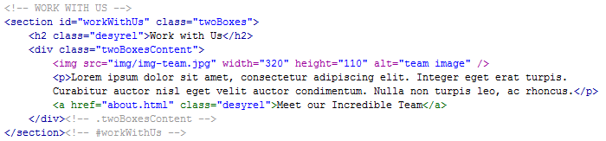

- the ourCheckList element contains a basic list. To edit it go within the element and change the content of the li elements.
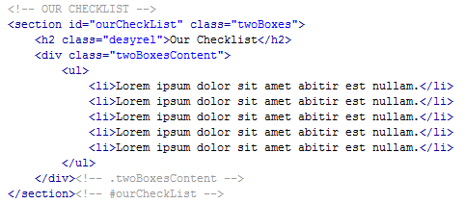

- The Footer
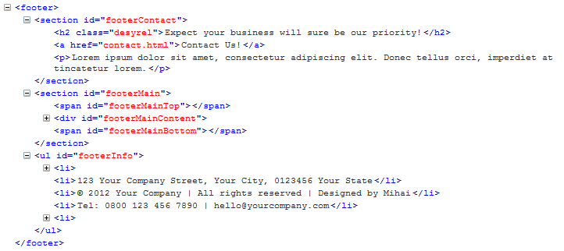
- the footerContact contains the orange box at the bottom on the pages. To edit it change the h2, a and p elements.
- The footerMain element contains the blue box at the bottom of the pages. It consists of 3 sections: footerLeft, footerRight and flickrStream. Go within each of these elements to change their elements.

Secondary pages
The structure of the content section of the secondary pages is shown below:
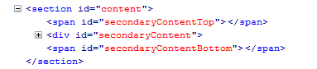
To change the content of the pages go inside the secondaryContent element.

ABOUT
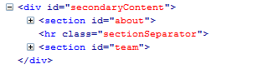
- The about section contains some article elements that you can edit to change the content.
- The team section contains a list of all the team members. You can edit the img, span and p elements to change the content of the section.

SERVICES
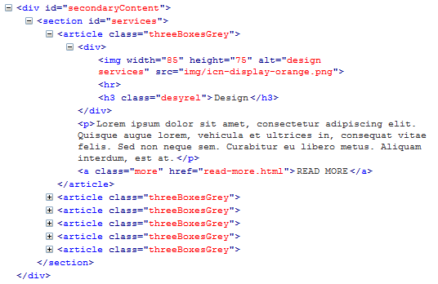
- The services section contains some article elements that you can edit. To change the content you need to edit the img, h3, p and a elements.

PORTFOLIO
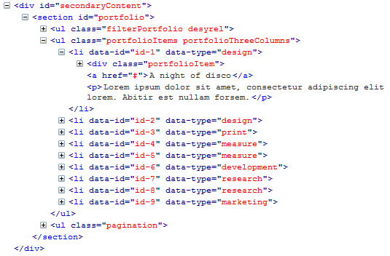
- The portfolio sections contains 3 main elements:
  - filterPortfolio - the categories by which you can filter the portfolio.
  - portfolioItems – contains the images and descriptions of the projects.
  - pagination – page numbers so you can easily navigate larger portfolios.
- edit the img, a and p elements in order to change the image, title and description of your projects.

PORTFOLIO PROJECT
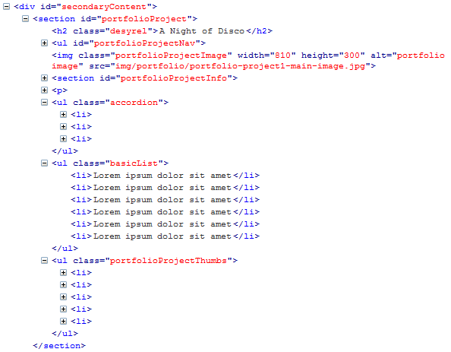
The most important elements in the portfolioProject section are:
- h2 which contains the title of the project
- img is the main image of the project
- portfolioProjectInfo which contains the client name, services performed on the project and a link
- accordion and basicList contain additional information on the project
- portfolioProjectThumbs contains a list of additional images for the project.

BLOG and BLOG POST
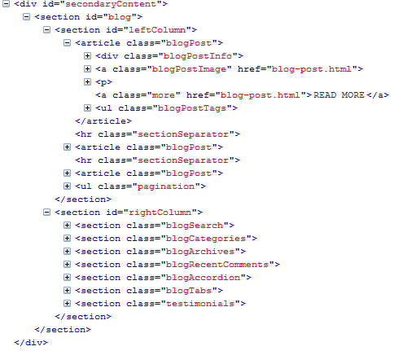
The blog pages consist of two main elements: leftColumn and rightColumn.
- The leftColumn contains article elements for each blog post. In each of the articles you can change the date, title, image and text of each of the posts.
- The rightColumn contains a few widgets. Go within each element to chage its content.
The single blog post page contains in adition a list element for the comments and a message form so the users can post their comments.

CONTACT
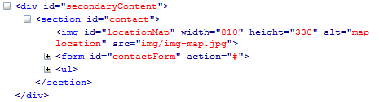
The contact page contains the following elements:
- An image of a map location which you can change with your own by editing the src attribute.
- A form element which contains the contact form.
- A list which contains the company info.
To use the working contact page you need to do the following:
- Go inside the “js” folder in the template root folder and open the mail.php file in your preferred editor.
- Change the email address where you want to receive the messages. You can also change the subject of the email that will inform you have received a message from the website.
- Rename the contact-working.php file to contact.php and change the link to the new contact page on each of the other pages.
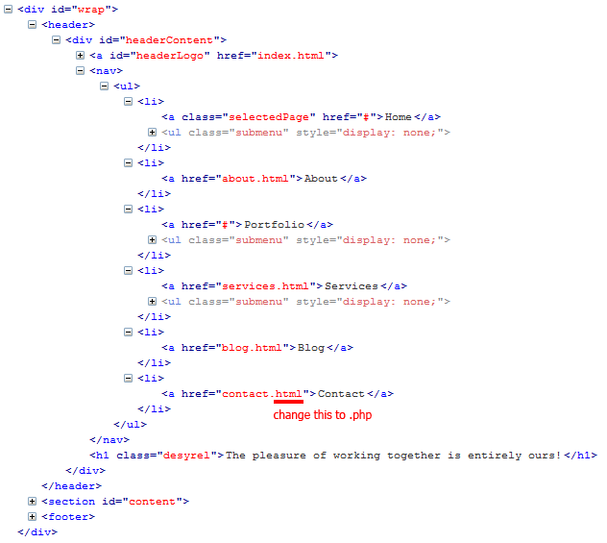
- Upload the site to your domain in order to test that it works.
THE CSS
The main CSS file is located in the “css” folder and is named screen.css.
The CSS file contains the following sections:
/*****************************  CSS RESET  *****************************/  /*****************************  GLOBAL STYLES  *****************************/  /*****************************  INDEX  *****************************/  /*****************************  INDEX SLIDESHOW  *****************************/  /*****************************  ABOUT  *****************************/  /*****************************  SERVICES  *****************************/  /*****************************  PORTFOLIO  *****************************/  /*****************************  PORTFOLIO PROJECT  *****************************/ | /*****************************  BLOG  *****************************/  /*****************************  BLOG POST  *****************************/  /*****************************  CONTACT  *****************************/  /*****************************  404 NOT FOUND  *****************************/  /*****************************  READ MORE  *****************************/

Each section of the CSS file has other sections for the different elements on each page.

The CSS file is made up of CSS rules that control the style and appearance of the elements in the HTML files.

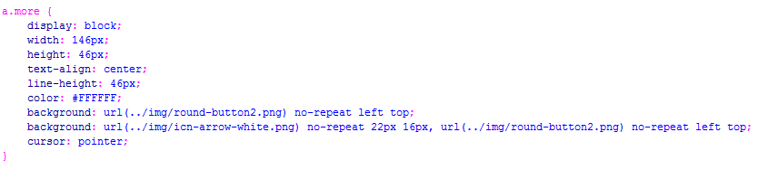
A CSS rule is made up of selectors and properties:
- “a.more” is a selector
- Between the { } we have the properties

In order to change the appearance of the elements in the HTML files you need to:
- identify the elements you want to change in the HTML files
- search for those elements in the CSS file
- change the properties of the rules that control the styling of those elements.

THE JAVASCRIPT FILES
The template imports 7 javascript files which are located in the “js” folder.

The only file that you should look over is “scripts.js” which contains custom scripts through which I achieved the effects and animations on the pages.

Okay, that does it.
This was a fairly simple tutorial for customizing your template. Please feel free to make any other changes you see necessary.
Thank you for buying the Blorange site template and I wish you lots of visitors.

